**GAME CONCEPT**

# Intro

Before the start, I tried to think as differently as possible. It may be a little difficult to comprehend, but I want to mix the good elements with the other team members with this.

The beginning makes it the same as a regular Flash game (any web games). I'm thinking of following the structure below. (If possible, it would be a web game based on HTML5 engine that Facebook is promoting.)

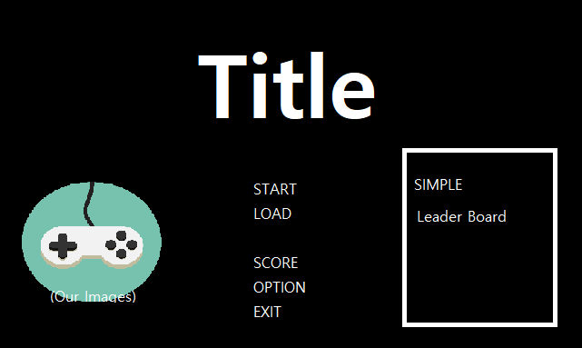

In the picture above, LOAD (button) depends on whether we configure a server or not. I will refer to the SCORE or the leaderboard section later.

**- Facebook Gaming (**[**link**](https://www.facebook.com/fbgaminghome/developers?sc=fbm.fb&mb&mp&scn=pg.b-d.a-i-s&mid=pg.b-d.a-i-s.fbhouse-corevalueprop-kr-ko.8250&wfid&__xts__%5b0%5d=68.ARA9DIDpqbd5ZEUoouq6rh1xId4CvMxLfX0lXGLamvYqV7Ys2u-0Wnw8-8jiH12shm8jD-3KVvoXOw9af3mLFI55mvQqogVaYeipXRlZ7b1Yrjumugk-HVFiZTStIzN9tLhiHsI6nVJKa-pXZY-lHwj-LhXeTUZtUV6Y6m77q-1dqQ7HoNt8-z7jLtqwQqemJreRUBcaylqjFrJ5OT8iQZts6PioxATb0093QXl6NRPRKkwmFzSrr1nFljPEYVJetL_7MaLArUO87IAhBes7im7LtmhtWFHVyllHqjD3G-8Vtpw1RyxHHDIkWf34y_CYSAjaZ4pjiGBYhXe14Hb4fNb6jMMjTnh42lMyFS0o_qzsfvIPR8EhJMf4bfI&__tn__=%2C%3CHHHH-R&fb_dtsg_ag=AQzSMlVM-TCgpLDvkKNF_sHXARvBAMaRYoRd6B-K0UQorg%3AAQzgUgjzdlA3Oh_c3yhXXi8FO769dOjA052ebSsY629eRw&jazoest=27812)**)**

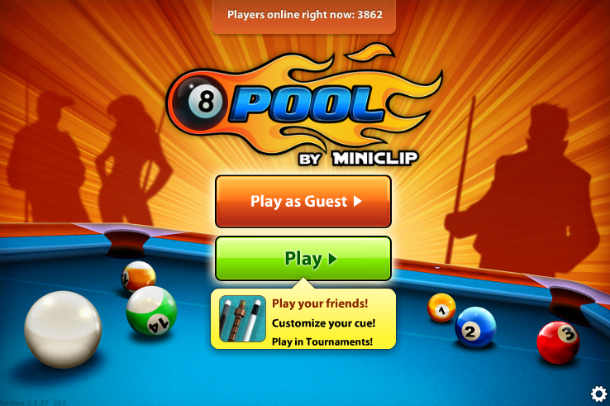

If we use Facebook gaming, we can freely use Facebook open APIs and thus have basic profit structures such as advertising. Moreover, we can create a multi-play structure easily or make server-side thinking simpler. There is already a tremendous ecosystem.

# Description

I hope that the game’s genre is stage-clear style’s casual. The theme of the game is "Get out of Cyber Bulling directly by one-self". We make the player a victim of cyberbullying. But here, you may wonder that cyberbullying is a diverse and comprehensive concept. I will explain the game from various angles to solve the question.

The game will be played as 2D pixel game, as shown in the picture below. Also, the view of the game camera will be fine in the form of a cross-scroll(횡 스크롤), not in the third person. And cell phones in the game will be the main media (main subject).

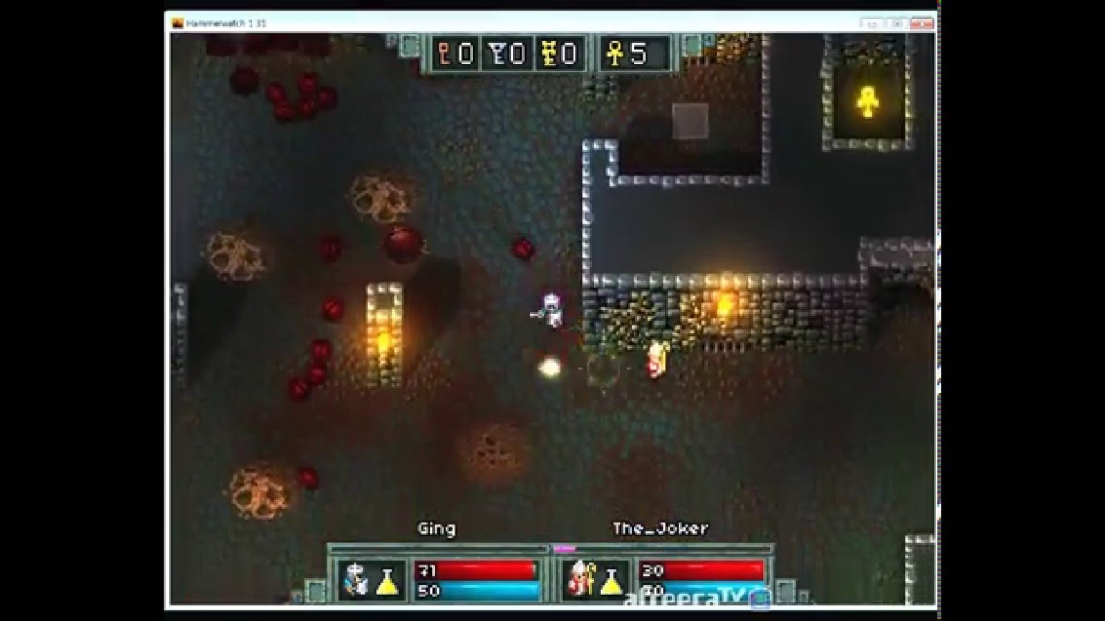

**- The Rules of the game**

For each stage, the player gets various information from the cell phone in the game. The stage is a small open world and player must choose how to solve the Cyberbullying on its own. The right choice soon leads to Stage Clear.

For example, suppose the player received a message that caused discomfort from someone he/she didn't know. On the map, there is a school, a police station, and own home with one’s parents. In school, there are options to show to my teacher or to watch with my friends. In police stations, player can file a complaint right away or choose to file a report. That's how it plays. It's not a good way to watch and share with all one’s friends. Moreover, it is not a good way to go to the police station and file a complaint right away. In this way, the player is asked to make a best choice depending on what type of cyberbullying he or she receives for each stage. Stages have a time limit. Players can gain the higher score by making decision better or fast one.

We can add the specialties of places to the map. Especially by adding the specialty of the place of school, it is possible to emphasize to young friends how to solve the problem.

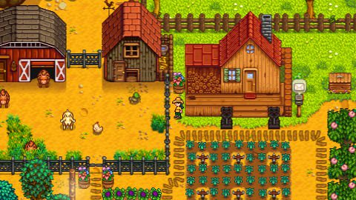

# Contents

The bottom line is that the game gives players the option to experience cyberbullying directly and to solve it directly by one-self. We can also make the situation that players face possible in terms of cyberbullying, along with MIL capabilities, depending on what kind.

# Platform

As I said at intro, I hope use Facebook API. First, the game should be a web-based. In terms of the Web, it should be made essentially into a cross-platform that can be used in any browser. However, it is better to use different frameworks for the platform itself to be free.

For example, if we try to make the Web-based game itself freely portable, we should use a framework dedicated to developing a hybrid-web-app called "Cordova". Then there will be a situation where servers will naturally be built, and the size of the project will naturally grow. Through things like web-app-viewer, we can create an environment that can be seen simply on mobile. It will be different when it comes to what choice we make.